**Uncovering the “black box” of algorithms: What’s behind your addiction?**

Source: Network Communication Magazine

Author: Li Kangle

Editor-in-charge: Yue Xiuyu

2018-04-19

<http://www.81.cn/theory/2018-04/19/content_8008082.htm>

Kevin Slavin said in his TED speech that algorithms are "distilled from this world, originated from this world", and now they are "beginning to shape this world". In an era when algorithms "shape the world", it is worth thinking about: how to break through the bottleneck of utilitarianism and give technology positive value?

**1**

**Don’t algorithms have values?**

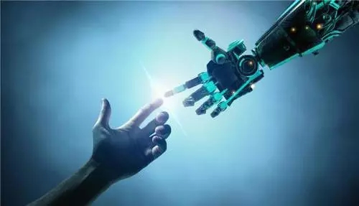

The biggest advantage of algorithms is that they can provide intelligent and precise recommendations based on the user's "digital self". In a sense, algorithms are a "shortcut" for people to quickly find what they need in the vast ocean of information. People trust algorithms based on their "objectivity". Google firmly believes that "our users trust our objectivity". Google's human-machine algorithm model attempts to emphasize "technical rationality", that is, "objectivity without human intervention". But does pure objectivity really exist?

Behind the algorithm are people. As a product of human wisdom, the algorithm undoubtedly needs to carry certain values. The source of the algorithm involves many factors. Human needs, interests, social environment, existing technologies, etc. will have an impact on the algorithm. The cognitive ability, knowledge level, design intention, and values ​​of the algorithm designer will also affect the algorithm. "Code is law", American scholar Lawrence Lessig believes that "although the code can be deregulated, the code itself is not fixed, but can be manipulated and changed by non-technical forces such as business and politics. People's behavioral cognition on the Internet is regulated, but this regulation is achieved by changing the code."

Each company's algorithm is different, and behind it are their purposes and values. We think we have a lot of power to choose information, but in fact all options are given by the algorithm. The algorithm determines to some extent what we can see and what we think is real. During the height of the Occupy Wall Street movement, Facebook did not recommend it in a prominent position. Those who use Facebook as their main source of information may think that this matter is not that important. Sociologists William Thomas and Dorothy Thomas said: "If people define a situation as real, this situation will have a real impact."

Although the aggregated news and information clients themselves do not engage in content production, they rely on channel advantages to exchange for media and self-media content supply. However, all pushed content actually carries certain values. The so-called "value-free" in social science research does not mean that there is no value, but refers to giving equal respect to content of different values, and giving information that does not conform to your values ​​to correct your values. Therefore, the view that algorithms have no values ​​is itself worth discussing.

**2**

**Do algorithms limit our thinking?**

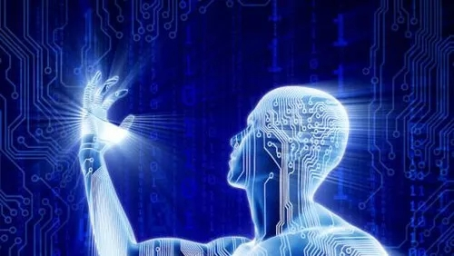

In a sense, algorithms are the product of minimalist culture. People are eager for standard answers to simplify the anxiety and confusion caused by the flood of information in the information age. In his book The Interface Effect, Alexander Galloway said that algorithmic culture tends to develop towards minimalism, which is "the inevitable consequence of not being able to consider the overall situation based on the current situation and not being able to interpret the present as history."

Algorithms are a kind of choice, and choice means giving up. Personalized recommendation of information is not essentially the user actively selecting information, but the active presentation of information. The information that users are exposed to is either the eye-catching 100,000+, or limited to the narrow field of their interest, or "spoiled" information that is consistent with their views and opinions. People are immersed in the information cocoon created by algorithms, losing the opportunity to contact different fields and different viewpoints, and their spiritual world will become narrow as a result. In the world of algorithms, people are just a collection of data points, and they are not understood and treated as individuals. The subtlety of human nature, the diversity of needs, and the complexity of emotions are far beyond what code can present.

Algorithms predict, influence, and then control user behavior. The limitations of algorithms on human thinking can also be seen in the auto-completion algorithm. The auto-completion algorithm was originally designed to help people with disabilities improve their typing speed, but later Google incorporated it into the service function to guess what users want to search for before they finish typing the search content to save time. However, the auto-completion algorithm brought a lawsuit to Google.

In 2012, Bettina Wulff, the wife of former German President Christian Wulff, accused Google's autocomplete algorithm of defamation and slander. When typing her name, the autocomplete would show search terms pointing to prostitutes and the escort industry. The court ruled that Google must ensure that the search terms generated by the autocomplete algorithm do not contain any offensive or defamatory content. Wulff won the lawsuit. Google claimed to be extremely "disappointed" with the verdict, believing that the verdict was an open questioning of Google's objectivity. A company spokesperson said: "Google should not be responsible for the search terms generated by the autocomplete algorithm, because these predictions are not made by Google itself, but are automatically made by the computer algorithm based on previous search records." In fact, for those users who originally did not know Wulff, after seeing the search information prompt, they are indeed likely to be guided in a certain direction. Algorithms can not only predict user behavior, but also influence and control user behavior.

Algorithmic technology makes many information behaviors of users not demand-oriented. Algorithms put specific options in front of users, so that users can only choose from the options provided. People's initiative in the process of obtaining information is greatly weakened. To a large extent, users are "fed" by the information provided by the algorithm, and this information is not all what users really need. Sometimes, information "encounter" becomes a long-planned information "tampering".

**3**

**"Self-rescue" in the era of algorithms**

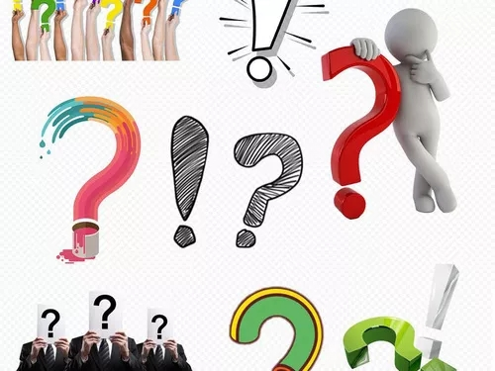

Doubts about algorithms have existed since their birth, and this doubt actually reflects human scientific rationality. While continuing to improve the design of algorithms, we must of course learn to "save ourselves", that is, to protect ourselves from algorithms.

Be aware of possible limitations of algorithms. For users, the biggest problem with algorithms is that they are not transparent. The complexity of algorithms is not something that even technical personnel can understand, let alone ordinary "tech novices". Although we only see the results given by the algorithm and know nothing about its design concept and operating logic, we should know that algorithms are not completely objective and may be distorted and biased. We must always be aware of possible limitations of algorithms and know that content that does not conform to our values ​​may have been blocked from view.

Keep the good habit of asking questions, and don't expect answers to come easily. In a world where all problems can be easily solved, people need a more radical mindset. When asking questions, try to understand what role the algorithms are playing, what they were originally designed for, and who the so-called "relevance" and "news value" are for. Some people have begun to study algorithmic data interference so that they can interfere or circumvent it when the algorithms try to understand them and classify them. Some people usually buy newspapers and browse news in traditional web ways, and try not to rely on smart searches, in order to use their own logic to fight against the narrowing of information that may be brought about by algorithms and not be restricted by algorithms.

In addition to uncovering the algorithm's "black box", we must also be able to control it. Throughout history, whenever new technologies emerge, it is difficult for people not to participate in them. We certainly cannot abandon algorithms, although the application of algorithms will still bring many problems. What we need to do is not only to understand the algorithm and the impact and changes it may bring to us, but also to be able to control it, use wisdom to seek benefits and avoid harm, and make the algorithm more scientific and rational.